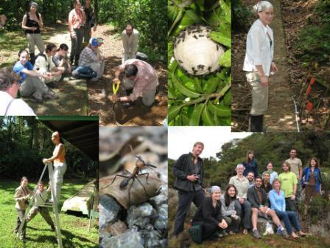
Open Enrollment: Behavior, Ecology and Diversity of Neotropical Social Insects

Social insects are major ecological players in terrestrial ecosystems. This 14-day course will be based at Las Cruces (mid-elevation) and La Selva (lowland wet forest), with short trips to other sites in different life zones. It is directed toward graduate students interested in social insect behavior, ecology and systematics. The course will cover an array of topics including social evolution, species richness, sampling methods, behavioral observations, and symbiotic associations. Faculty will present workshops on their taxa and topics of expertise. Students will participate in faculty led and independent field problems on social insect behavior and ecology.

Instructor: Sean O’Donnell, Professor of Biology, Drexel University
Dr. Sean O'Donnell is very excited to have the chance to teach this course again. Students in the first offering ranged from senior PhD students to post-bachelors students still considering grad school, and everyone gained a great deal from the experience. The 2012 course will add more time at the second site (Las Cruces) for student projects, and welcome co-instructor (2009 course alumna) Dr. Floria Mora-Kepfer.

Course dates: March 17 - 31, 2012
Application Deadline: October 15, 2011
(followed by rolling admission)
For more information and application form, please click here.

